CHOPOK
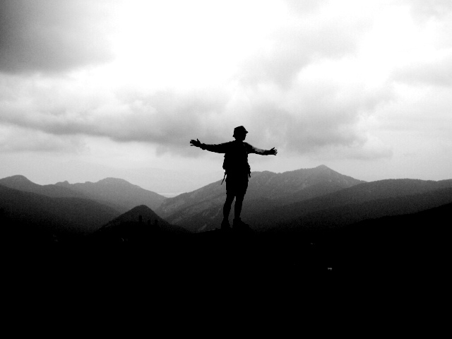
After Terchova we went to Demanovska dolina where we had vacationed in Paucina Lehota during the winter of 2005 :
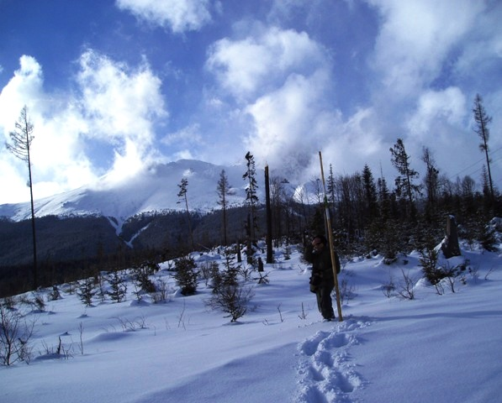
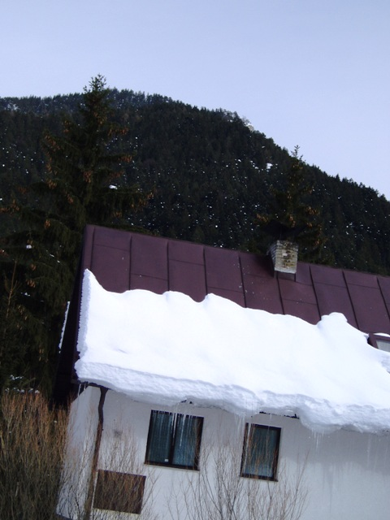
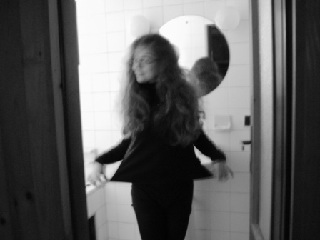
This time we stayed in the nearby village of Demanova at the cottage of Lubka’s brother’s girlfriend’s family .
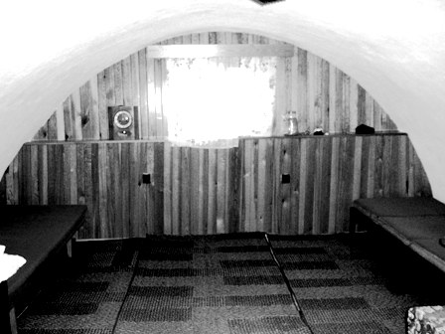
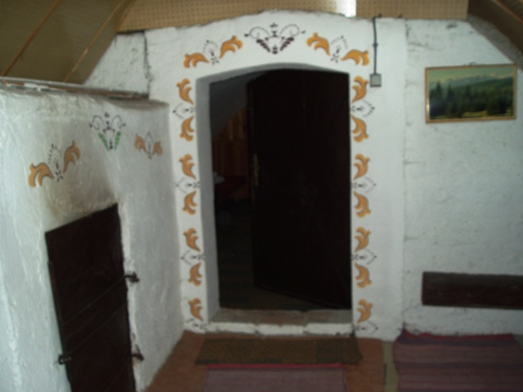
Our first hike in Demanovska dolina was Jasna to Chopok (the second highest peak in the Low Tatras at 2,024 meters) .
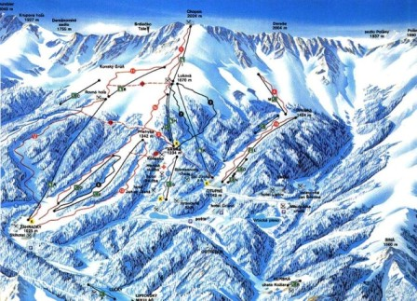
From Jasna we started out alongside ghost town chairlifts and ski slopes and slowly up towards thick, green woods.
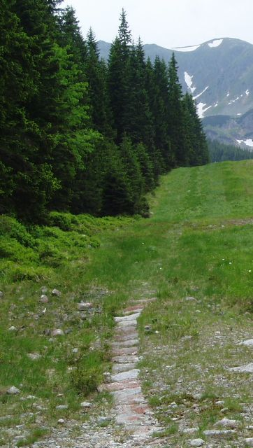
We spent a large part of the woodland trail in a thicket of roots and downed trees following rock lined furrows cut by the torrent of melting snow in the early spring.
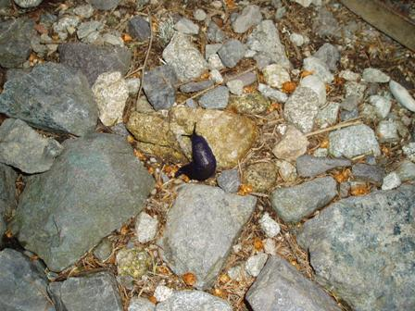
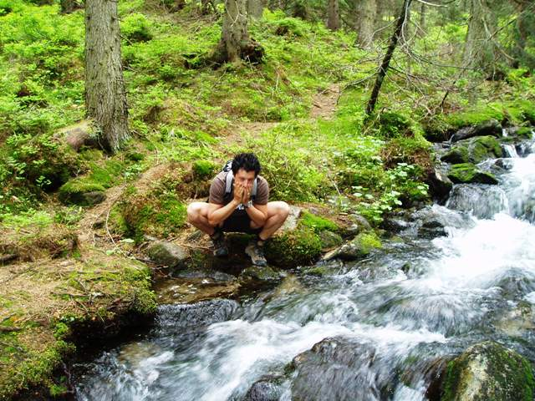
As we approached Lukova the forest started to thin and open up again
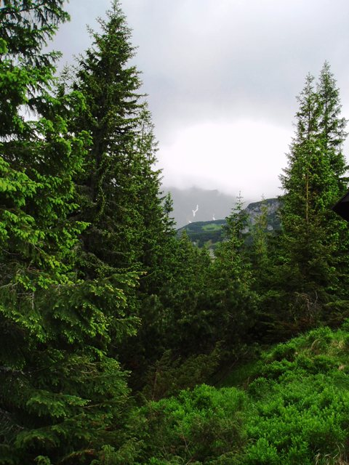
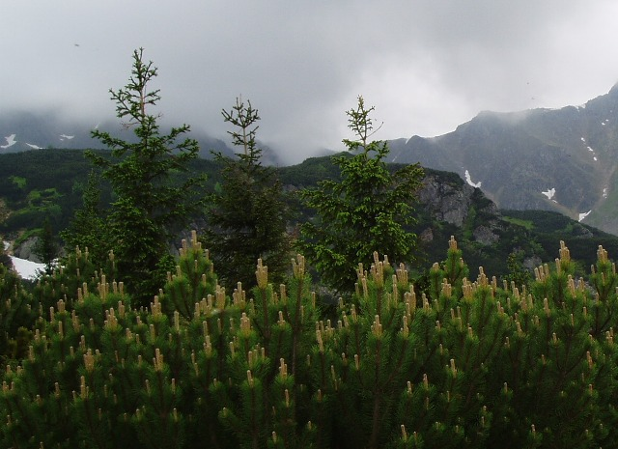
showing the more characteristic, higher altitude flora and cloud covered peeks.
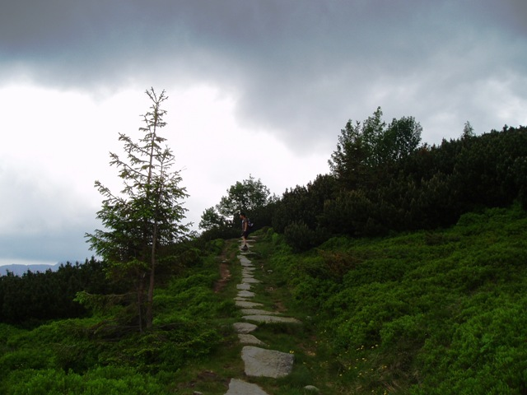
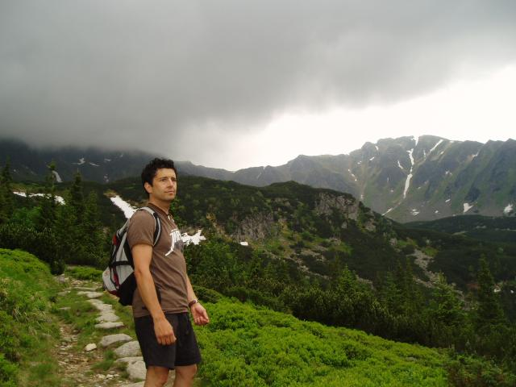
By the time we reached Lukova, the telltale signs of approaching thunderstorms had become a legitimate concern. So with a light rain already falling and a couple hour hike back to Jasna, we decided to forego the full hike and descend the heavens back to terrestrial mooring
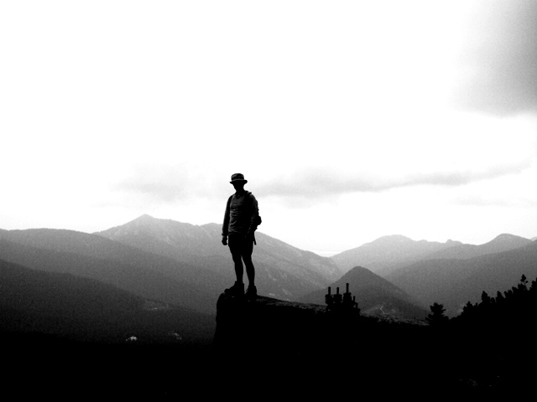
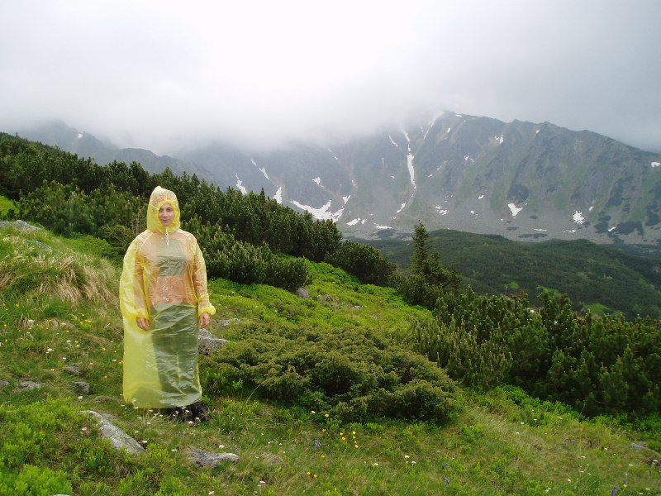
CHOPOK* We had planned to stay at a cottage in Sklabina and arranged to pick up the keys from a woman in the outlying village who watched over it for the owner. The owner had warned us that it was a simple, quiet cottage with no hot water, and this was exactly what we wanted. Sometimes empty buildings and homes (and such) have a feeling about them apart from their appearance. Well everything there—the kitchen, the stairs, the beds, the lights, the yard—had the unmistakable chill of a nightmare, and the feeling was so strong that we quickly decided not to stay even though we’d prepaid and had gotten so late a start out of Terchova that it was now almost dark. When we drove back to the village to return the keys to the caretaker and explain that there was a definite difference between simple and uninhabitable, she told us that she understood, and that after the last people had left, “vyzeralo to, ako keby sa tam rezali…steny boli postriekane krvou!”


